HOWE, Germany, 2018-04-12

I have ported the existing CyScope project originally available for the CY8CKIT-059 to the [Sparkfun FreeSoC2](https://www.sparkfun.com/products/13229). Additionally, a prototype PCB was build that allows to loop by jumpers the output signals (waveform generator, PWM, inverted PWM and DigitalOut0) to the scope inputs ‘A’ respectively ‘B’. If no jumper is set, then a standard scope probe (not included in that package) could be connected to the BNC connector. A dip-switch allows to drive high/low signals to digital inputs 1-4.

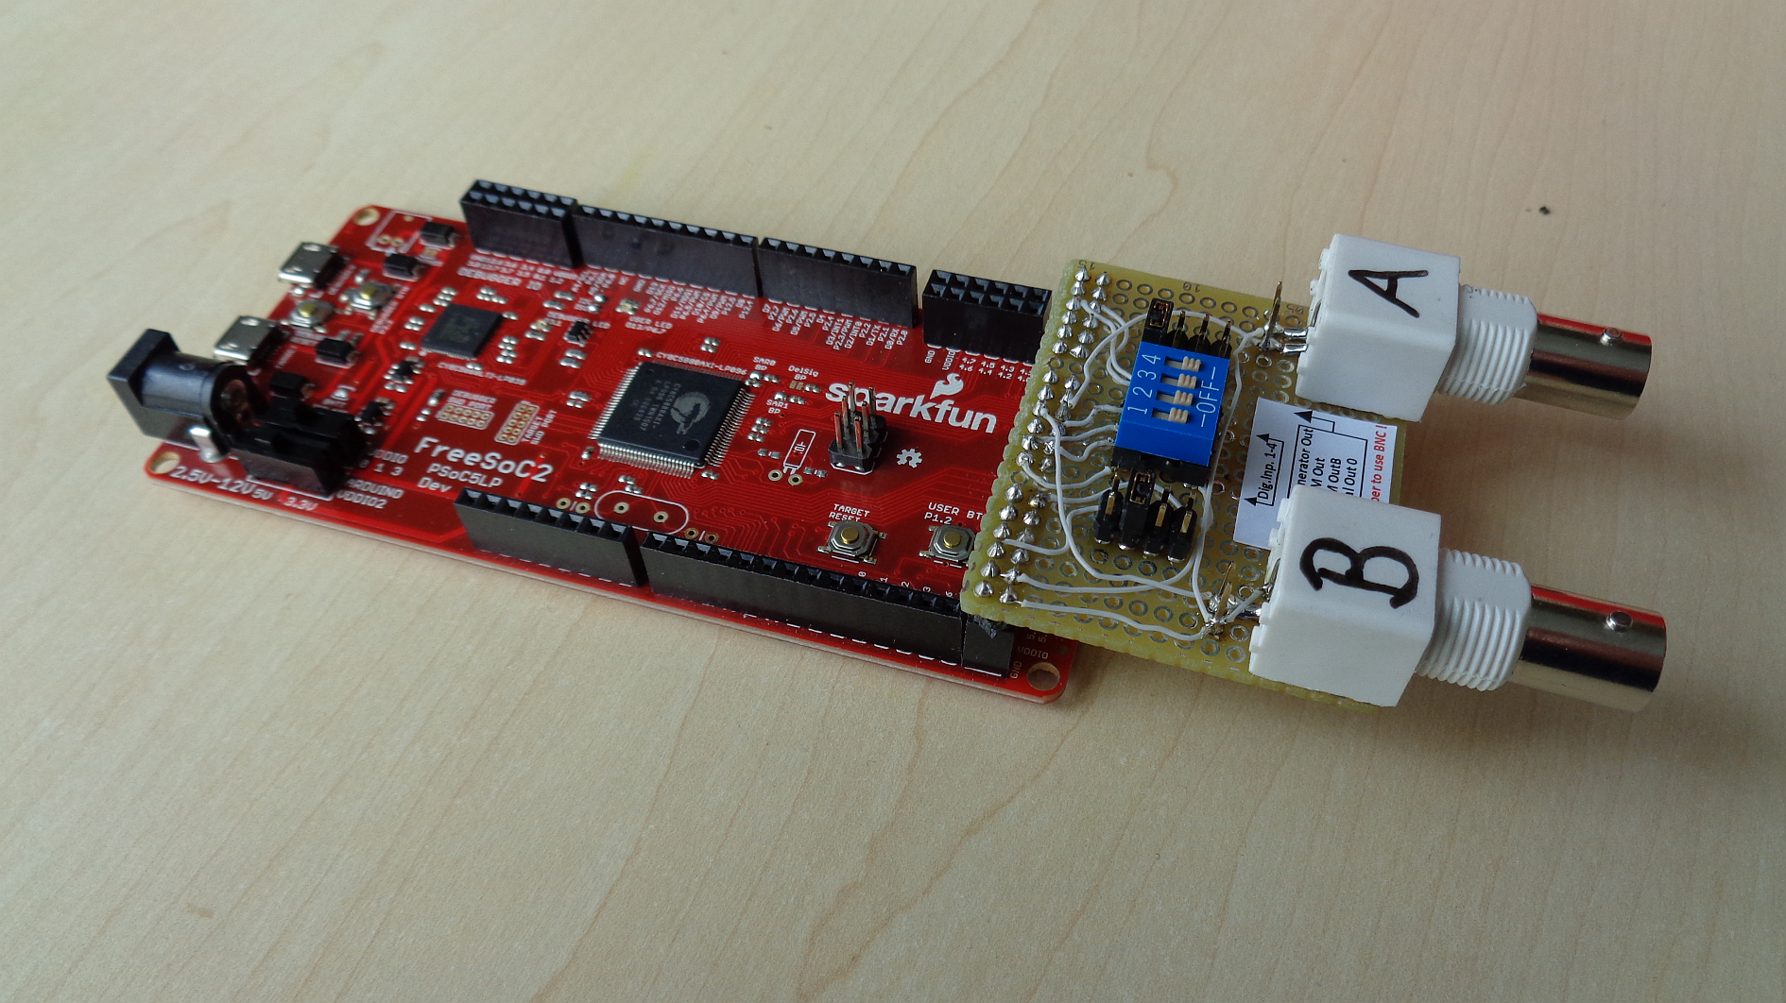

The [Sparkfun FreeSoC2](https://www.sparkfun.com/products/13229) board is based on PSoC5LP, too, but uses a device with higher pin count, offers Arduino-style pin header and has additional headers for the lasting ports. This board is often distributed by Cypress on exhibitions, maker fairs and student events. Hence it makes sense to make that impressive oscilloscope software example available for FreeSoC2 kit, too.

# Firmware / Creator project:

The original CY project (for -059 kit) is available here:

<https://github.com/cypresssemiconductorco/CyScope>

Following modifications have been done:

1. The PSoC device was changed from CY8C5888LTI-LP097 (used on CY8CKIT-059 kit) to CY8C5888AXI-LP096 (used on FreeSoC2).
2. To run that project on the FreeSoC2 the pin mapping has been changed (see Figure 1) in order to have all signals available on the right-hand side located three 12-pin headers.

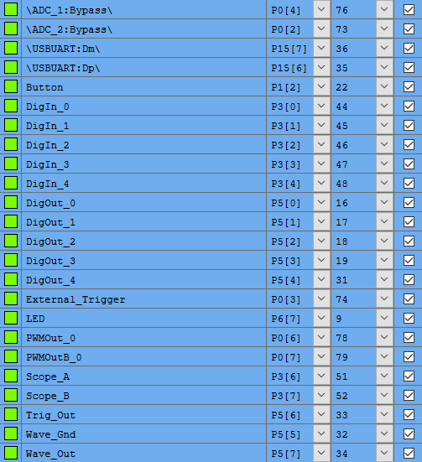

Figure 1: New pin mapping (.cydwr file) used for FreeSoc2

1. An inverter has been added to the button input to match the FreeSoC2 button polarity.
2. Resistive pull-ups have been enabled for all DigIn[0..4]. Previously DigIn[3,4] had pull-down resistors.

No other project modifications have been done.

The new project is attached and will be added to the above mentioned github project.

# Hardware:

A prototype PCB was build that allows to loop by jumpers the output signals (waveform generator, PWM, inverted PWM and DigitalOut0) to the scope inputs ‘A’ respectively ‘B’. If no jumper is set, then a standard scope probe (not included in that package) could be connected to the BNC connector. A dip-switch allows to drive high/low signals to digital inputs 1-4.

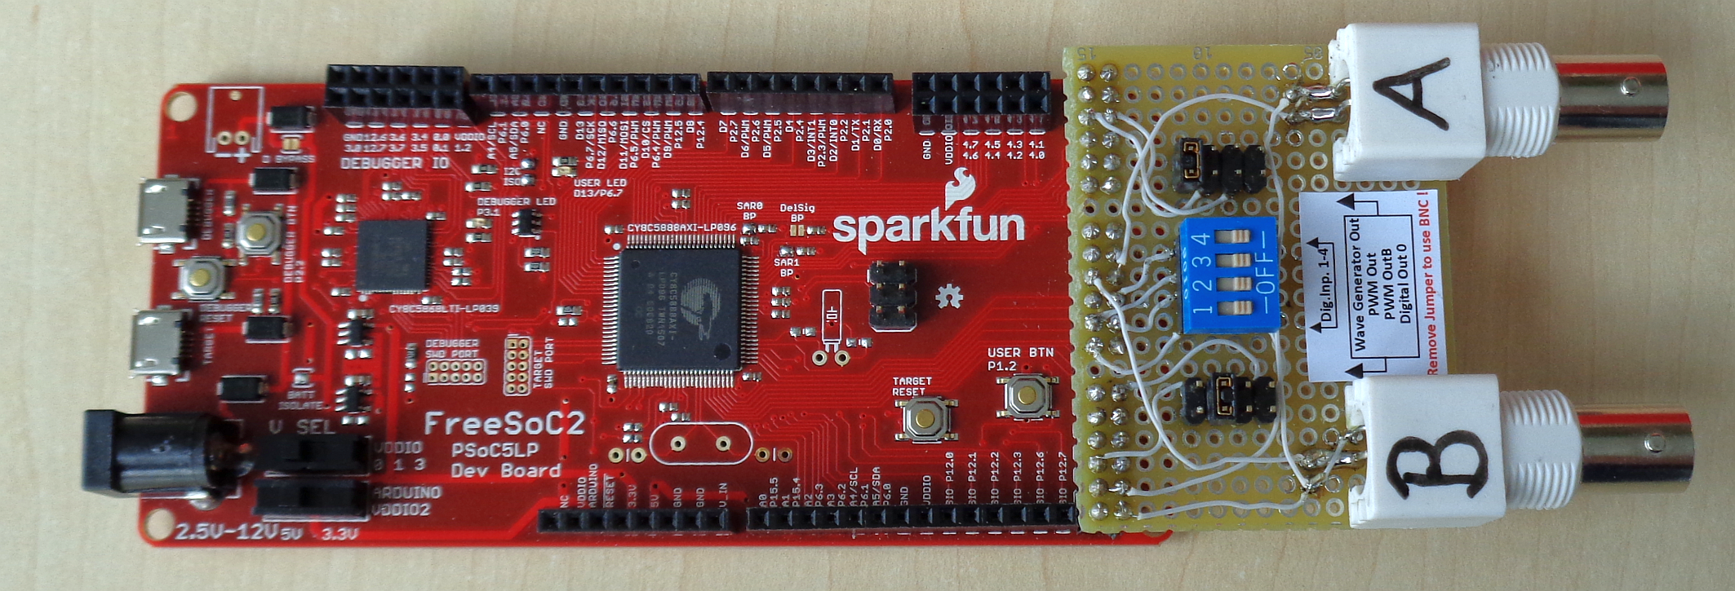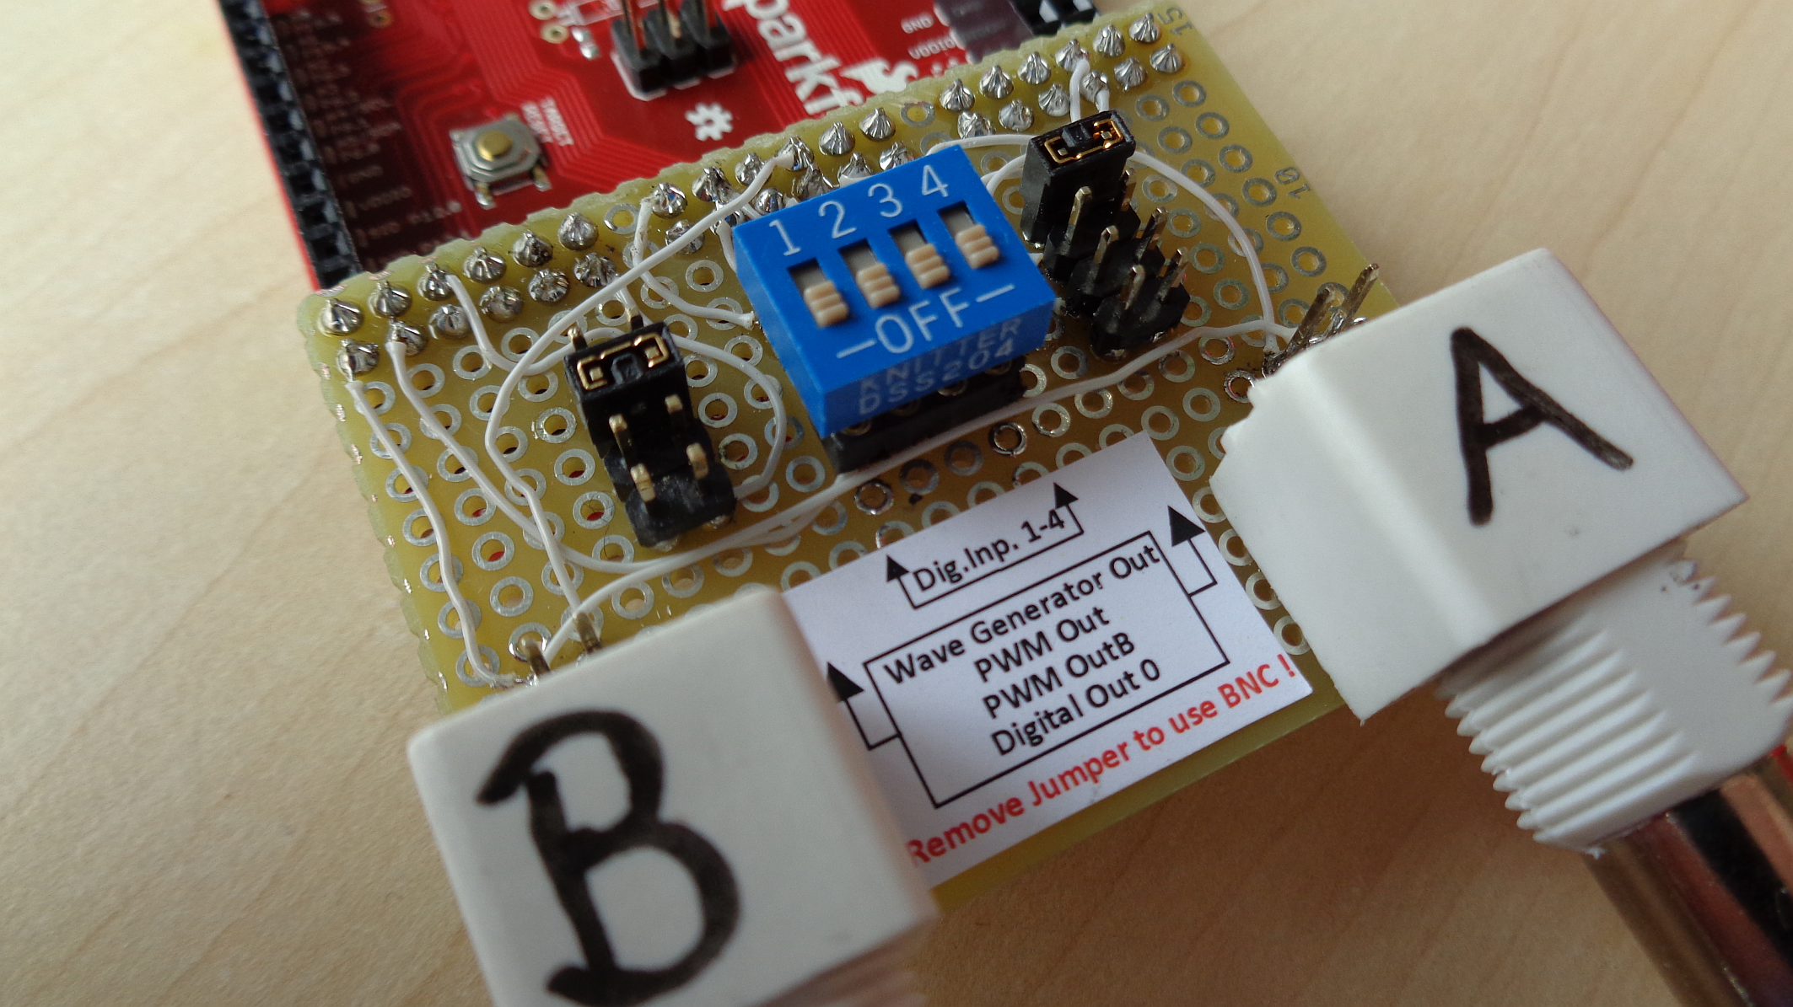

|  |  |  |  |  |  |  |  |  |  |  |  |  |  |  |  |  |  |  |  |
| --- | --- | --- | --- | --- | --- | --- | --- | --- | --- | --- | --- | --- | --- | --- | --- | --- | --- | --- | --- |
| **GND** | **VDDIO** | **Wave Out** | **Wave**  **GND** | **Dig**  **Out3** | **Dig**  **Out1** |  | **Dig**  **In1** | **Dig**  **In3** | **Dig**  **In5** | **Scope**  **B** | **VDDIO** | **GND** |  | **P0[1]** | **Extern**  **Trig** | **P0[5]** | **PWM**  **OutB** | **VDDIO** | **GND** |
| **GND** | **VDDIO** | **Trig**  **Out** | **Dig**  **Out4** | **Dig**  **Out2** | **Dig**  **Out0** |  | **Dig**  **In0** | **Dig**  **In2** | **Dig**  **In4** | **Scope**  **A** | **VDDIO** | **GND** |  | **P0[0]** | **ADC2**  **Bypas** | **ADC1**  **Bypas** | **PWM**  **Out** | **VDDIO** | **GND** |
|  |  |  |  |  |  |  |  |  |  |  |  |  |  |  |  |  |  |  |  |
|  |  |  |  |  |  |  |  |  |  |  |  |  |  |  |  |  |  |  |  |
|  |  |  |  |  |  |  |  |  |  |  |  |  |  |  |  |  |  |  |  |
|  |  |  |  |  |  |  |  |  |  |  |  |  |  |  |  |  |  |  |  |
|  |  |  |  |  |  |  |  |  |  |  |  |  |  |  |  |  |  |  |  |
|  |  |  |  |  |  |  |  |  |  |  |  |  |  |  |  |  |  |  |  |
|  |  |  |  |  |  |  |  |  |  |  |  |  |  |  |  |  |  |  |  |
|  |  |  |  |  |  |  |  |  |  |  |  |  |  |  |  |  |  |  |  |
|  |  |  |  |  |  |  |  |  |  |  |  |  |  |  |  |  |  |  |  |
|  |  |  |  |  |  |  |  |  |  |  |  |  |  |  |  |  |  |  |  |
|  |  |  |  |  |  |  |  |  |  |  |  |  |  |  |  |  |  |  |  |
|  |  |  |  |  |  |  |  |  |  |  |  |  |  |  |  |  |  |  |  |
|  |  |  |  |  |  |  |  |  |  |  |  |  |  |  |  |  |  |  |  |

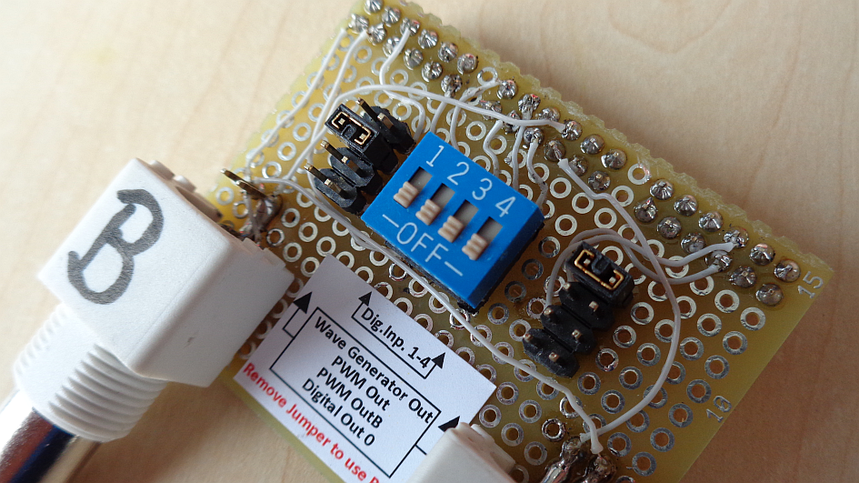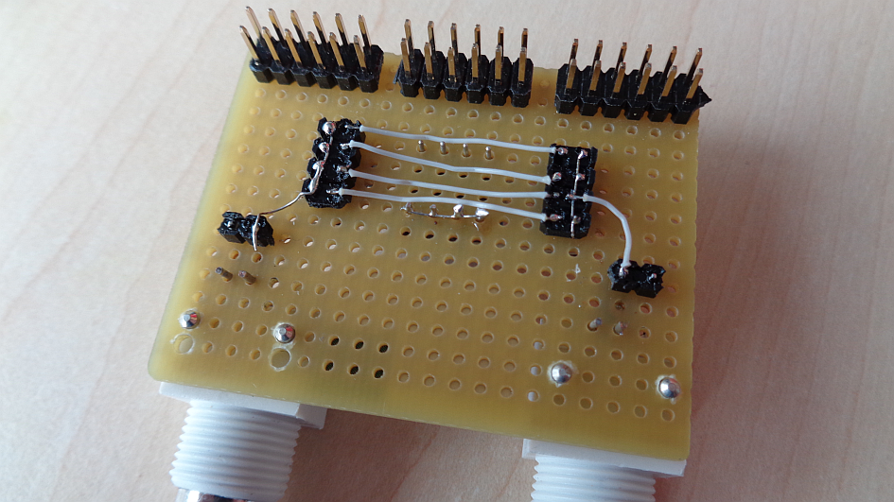

**Note:** The routing of the BNC connector depends on the supplier. Ensure that the scope A/B signal is connected to the BNC center, while GND is connected to the shield.

A small label explains the function of the jumper and the dip-switch

**Dig.Inp. 1-4**

**Wave Generator Out**

**PWM Out**

**PWM OutB**

**Digital Out 0**

**Remove Jumper to use BNC !**

# PC Software:

The CyScope GUI can be used without any modification.

< Have fun >